


Korea Lunar Exploration Program
DTNPL Software Requirement Specification

Date: 28 Dec. 2017 | Doc. No: KPLO-D0-550-200  Issue: 1.0  Total page: 13

Superseding Revised

Prepared By:  Hyun-Woong Choi Date  DTN SBC S/W Engineer, Lumir  Dae-Soo Oh Date  DTN SBC Engineer, Lumir |  | Kyung-Rak Lee Date  DTN Payload Engineer, ETRI
Reviewed By:  Jin-Ho Jo Date  DTN System Engineer, ETRI |  | Sin-Ae Ji Date  Proximity-1 System Engineer, ETRI
Sang-Man Moon Date  RLE KPLO Electrical System, KARI |  | Hyun-Jin Shin Date  RLE KPLO Mechanical System, KARI
Approval Signature:  Byoung-Sun Lee Date  DTN Project Leader, ETRI |  | Il-Young Kim Date  RLE KPLO Product Assurance, KARI
Seong-Bin Lim Date  Head, Lunar Exploration System Team, KARI |  | Seok-Weon Choi Date  Director, Lunar Exploration Program Office, KARI

Original CDMO Release__________________

Revision History
Version | Author(s) |  | Date | Description
0.1 | Hyun-Woong Choi |  | 2017. 12. 28 | Draft

Revision/Change Records
Version | Date | Revision/Change Description | Pages
0.1 | 2017. 12. 28 | Initial | All

Documents Tree

Contents

1. Introduction 7
1.1. Purpose and Scope 7
1.2. Applicable Documents 7
1.2.1. ETRI Documents 7
1.2.2. Other Documents 7
1.3. Abbreviations 7
2. Overview of KPLO DTN 9
2.1. DTN and Space Communications 9
2.2. Mission of DTN Operation 9
2.3. DTN Configurations 9
2.4. Communication Nodes 10
2.4.1. DTN nodes 10
2.4.2. Non-DTN nodes 10
3. Software Requirement Specification 11
3.1. Functional Requirement 11
3.1.1. DTN Protocols 11
3.1.2. DTN User Utilities 11
3.1.3. DTNPL Test Modes 11
3.1.4. One Way Test Mode 11
3.1.5. Round Trip Test Mode 11
3.1.6. Health Report 11
3.1.7. Fault, Detection and Recovery 11
3.2. Performance Requirements 11
3.2.1. Data Interface Speed 11
3.2.2. Life Time 11
3.2.3. Reliability 12
3.3. Interface Requirements 12
3.3.1. Data Interface 12
3.3.2. Data Interface Format 12
3.3.3. PPS Interface 12
4. Verification Matrix 12

Figures

Figure 2.1 DTN test configuration in the first phase 10

Introduction

Purpose and Scope
This document defines the electrical and mechanical interfaces between KPLO bus and DTN payload.

Applicable Documents

ETRI Documents
Document Number | Document Title
KPLO-D0-550-000 | System Requirement of DTN Payload
KPLO-D0-550-001 | System Specification of DTN Payload

Other Documents
Document Number | Document Title
KPLO-SP-310-001 | KPLO System Specification Document
KPLO-SP-340-001 | KPLO Payload/Spacecraft Bus ICD

Abbreviations
AMS | Asynchronous Message Service
BP | Bundle Protocol
BSS | Bundle Streaming Service
CCSDS | Consultative Committee for Space Data Systems
CFDP | CCSDS File Delivery Protocol
DCC | DTN Control Center
CRC | Cyclical Redundancy Check
DMA | Direct Memory Access
DTN | Delay(Disruption) Tolerant Network
DTNPL | DTN Payload
EOD | End of Data
EOF | End of File
FW | Firm Ware
FSW | Flight Software
ION | Interplanetary Overlay Network
KDSA | Korea Deep Space Antenna
KPLO | Korea Pathfinder Lunar Orbiter
LCM | Lander Communication Model
LTP | Licklider Transmission Protocol
MOC | Mission Operation Center
OBC | On Board Computer
OBT | On Board Time
PDHU | Payload Data Handling Unit
RCM | Rover Communication Model
RFU | Reserved for Future Use
SBC | Single Board Computer
SOD | Start of Data
SOF | Start of File
SOH | Start of Head
TBC | To Be Confirmed
TBD | To Be Defined
TC | Tele-command
TCP | Transmission Control Protocol
TM | Telemetry
UART | Universal Asynchronous Receiver Transmitter
USRT | Universal Synchronous Receiver Transmitter

Overview of KPLO DTN

DTN and Space Communications
Delay/disruption tolerant networking (DTN) technology offers a new solution to highly stressed communications in space environments, especially those with long link delay and frequent link disruptions in deep space missions. Delay/disruption tolerant networking (DTN) technology offers a new solution that use a store-and-forward mechanism to combat long link delay and frequent link disruptions generally characterizing space communications. DTN communications use a bundle protocol (BP), to construct a store-and-forward overlay network. The BP, situated at the application layer of the Internet model, utilizes conventional Internet protocols to send and receive data bundles. The benefits of DTN communications are as follows.
- Interoperability and Reuse: A standardized DTN protocol suite enables interoperability of multi-agency communication assets and also allows NASA to use the same communication stack for future missions (LEO, NEO or Deep Space).
- Space Link Efficiency, Utilization and Robustness: DTN enables more reliable and efficient data transmissions resulting in more usable bandwidth. DTN also improves link reliability by having multiple network paths and assets for potential communication hops.
- Security: The DTN Bundle Security Protocol (BSP) allows for integrity checks, authentication and encryption, even on links where not previously used.
- Quality of Service: The DTN protocol suite allows for many priority levels to be set for different data types, ensuring that the most important data is received ahead of less important data.
- Improved Operations and Situational Awareness: The DTN store-and-forward mechanism along with automatic retransmission provides more insight into events during communication outages and significantly reduces the need for ground-based scheduling.

Mission of DTN Operation
The mission of DTN is to validate DTN communication protocols by space link testing through KPLO. So DTN operations are focused on testing the DTN protocols using KPLO space links.

DTN Configurations
In the first phase of lunar exploration, test lunar orbiter called Korea Pathfinder Lunar Orbiter (KPLO) will be launched without lunar lander. Figure 2.1 shows DTN configuration in first phase of lunar exploration. There are no Lander and Rover on the moon in first phase. So Lander Communication Model (LCM) and Rover Communication Model (RCM) will be located on earth for the DTN communication testing.
DTN Payload (DTNPL) is a DTN node in the space. DTNPL will be mounted on the KPLO for DTN communication. DTN Control Center (DCC) is a control center of DTN communication nodes. LCM and RCM are DTN nodes on ground. All DTN nodes on ground are interconnected by the terrestrial network such as Internet. Mission Operation Center (MOC) and Korea Deep Space Antenna (KDSA) are not DTN nodes. They just transfer DTN packets to next communication nodes.

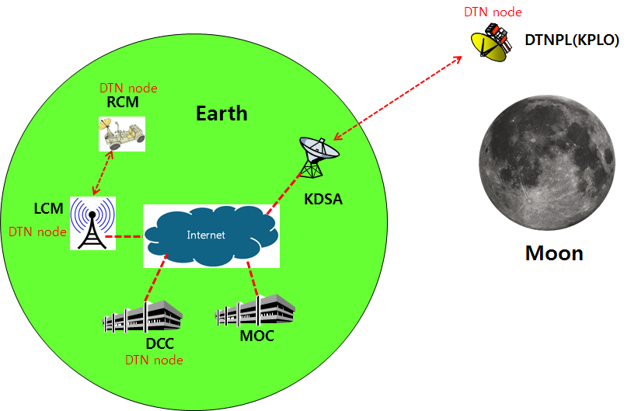
Figure 2.1 DTN test configuration in the first phase

Communication Nodes
Many communication nodes are needed for the DTN operation. Some of communication nodes in the network are DTN nodes whereas otherwise nodes are non-DTN nodes. The function of communication nodes used in the DTN operation is as follows.

DTN nodes
- DCC is a ground DTN node which monitor and controls DTN nodes. DCC send commands to DTN nodes such as DTNPL, LCM and RCM. It also receives telemetries or acquired data from some DTN nodes such as RCM or LCM.
- DTNPL is a DTN node mounted on the KPLO. DTNPL can be operated as a DTN end point. And it also can be operated as relay nodes which relay DTN data between DCC and RCM or LCM.
- LCM is a ground DTN node. LCM relays DTN data between MOC and RCM.
- RCM is a ground DTN node and a DTN end point. The commands sent by the DCC is terminated at the RCM and the RCM returns telemetry or data to DCC through KPLO.

Non-DTN nodes
- MOC is a non-DTN node. MOC monitors and controls KPLO and payloads. MOC also receives and processes data generated from the payloads and transfers to each payload control center.
- KDSA is a ground station for deep space communication. KDSA will have a big size of antenna and RF equipment for space link interface. KDSA also has network equipment for terrestrial communication interface such as SLE link. KDSA is a non-DTN node.

Software Requirement Specification

Functional Requirement

DTN Protocols
The DTNPL shall support DTN protocols which include at least Bundle Protocol (BP) and Licklider Transmission Protocol (LTP).

DTN User Utilities
The DTNPL shall support DTN user utilities which include CCSDS File Delivery Protocol (CFDP), Asynchronous Message Service (AMS) and Bundle Streaming Service (BSS).

DTNPL Test Modes
The DTNPL shall support two kinds of tests, one-way test and round-trip test as defined in the document named ‘Operation concept of DTN’.

One Way Test Mode
The DTNPL shall be capable of performing test of AMS, CFDP and BSS for one-way test mode.

Round Trip Test Mode
The DTNPL shall be capable of performing test of AMS and CFDP for roundtrip test mode.

Health Report
The DTNPL shall reports it’s health status to KPLO OBC for the reliable operation.

Fault, Detection and Recovery
Autonomous fault detection shall be provided to monitor the health of DTNPL and to perform corrective procedures in the event of any anomaly.

Performance Requirements

Data Interface Speed
The DTNPL shall have enough speed of data interface for the communication with KPLO.

Life Time
The operational life time of the DTNPL shall be no less than 1 year from the entering lunar orbit.

Reliability
DTNPL reliability shall be more than 0.7 over the operational life time.

Interface Requirements

Data Interface
The DTNPL shall have serial data bus interface for the communication with KPLO.

Data Interface Format
DTN transaction data shall be compatible with CCSDS DTN standards and RFC specifications.

PPS Interface
The DTNPL shall have PPS interface for receiving PSS signal from the KPLO.

Verification Matrix
The verification matrix is shown below.

SRS ID | Title | Methods
SRS ID | Title | T | A | I | D | S
SRS-DPL-10010 | DTN Protocols |  |  |  | O
SRS-DPL-10020 | DTN User Utilities |  |  |  | O
SRS-DPL-10030 | DTNPL Test Modes |  |  |  | O
SRS-DPL-10040 | One Way Test Mode |  |  |  | O
SRS-DPL-10050 | Round Trip Test Mode |  |  |  | O
SRS-DPL-10060 | Health Reports |  |  |  | O
SRS-DPL-10070 | Fault, Detection and Recover |  |  | O
SRS-DPL-20020 | Data Interface Speed |  |  |  | O
SRS-DPL-20040 | Life Time |  | O
SRS-DPL-20050 | Reliability |  | O
SRS-DPL-30030 | Data Interface |  |  | O
SRS-DPL-30040 | Data Interface Format |  |  | O
SRS-DPL-30050 | PPS Interface |  |  | O

